Chapter 7, Solution 16.

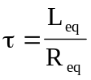
(a) 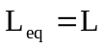 and 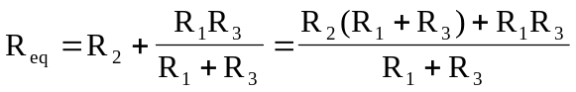
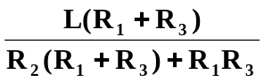

(b) where 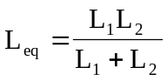 and 